**Game Design Document – SpaceRace (working title)**

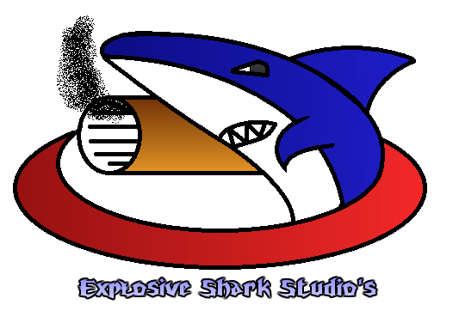

Sebastiaan van Dijk

Nick Kortleve

Jan Willem Jozic

Lionel Mithoe

Bart Dikmans

Contents

Summary 2

High level concept 3

Design goal 3

Visuals 3

Audio 5

Screen Passage 6

Formal Elements 6

Players 6

Objectives 6

Procedures 6

Game 7

Rules 7

Resources 7

Conflict 8

Boundaries 8

Outcome 8

Dramatic Elements 8

Challenge 8

Play 8

Premise 8

Target Audience 8

Visueel 9

Audio 9

# Summary

## High level concept

* Player vs Player
* Racing game over 2 axis (In mijn hoofd zie ik de speler niet over andere mensen heen kunnen vliegen maar hoveren ze boven de planeet en ben je wat Y-as betreft gelimiteerd aan wat de race track je biedt).
* 12-30 years old De game is erg fast paced met weinig reactie tijd. Redelijk extreem voor ‘Casual’ en oudere gamers.

## Design goal

* Race game with a lot of speed. (In mijn hoofd heeft de speler niet heel veel vrijheid en is relatief gelimiteerd tot het volgen van de track)
* Big race tracks
* Interaction with other players by shooting them (Sinds we ‘hoveren’ over een planeet en Alex zei dat het misschien geen slim idee is om daar nog eens de hele ruimte bij te betrekken, kan er niet worden gedogfight, wat ik denk dat ook slim is).

## Visuals

**Either**

* Relatively high quality graphics.
* Space like environment.
* With gameplay like this

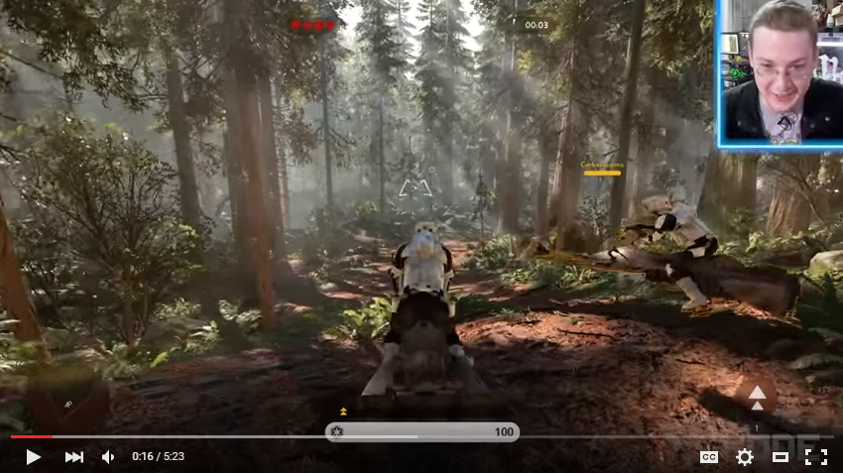

<https://www.youtube.com/watch?v=9nYb-G7qohQ>

* On terrain like this

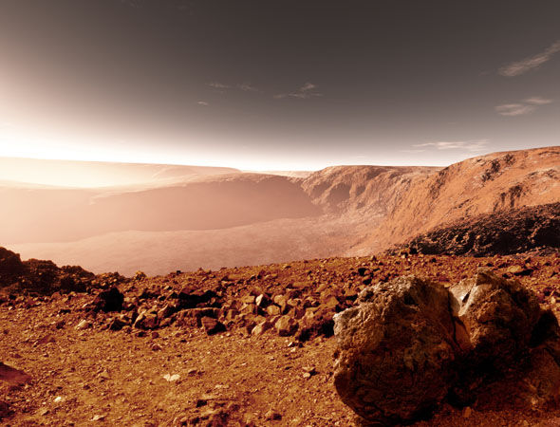 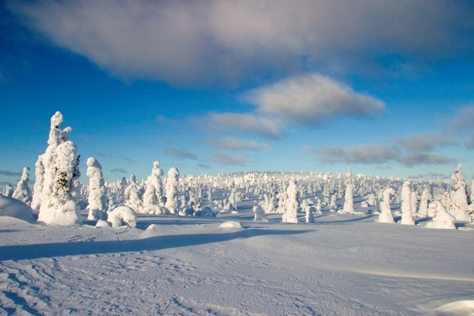

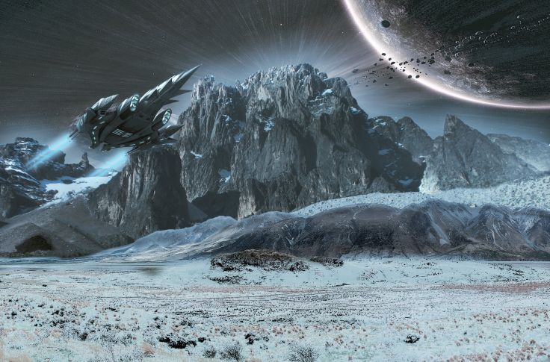 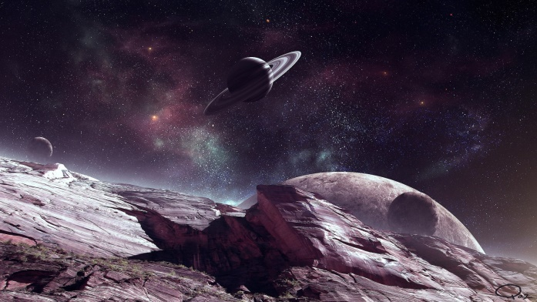

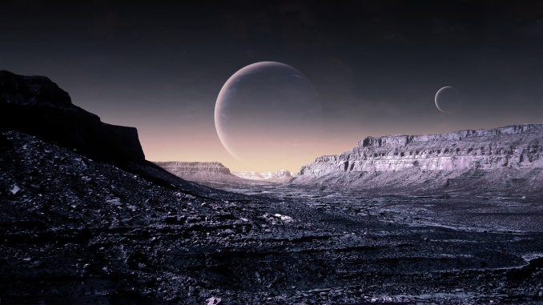 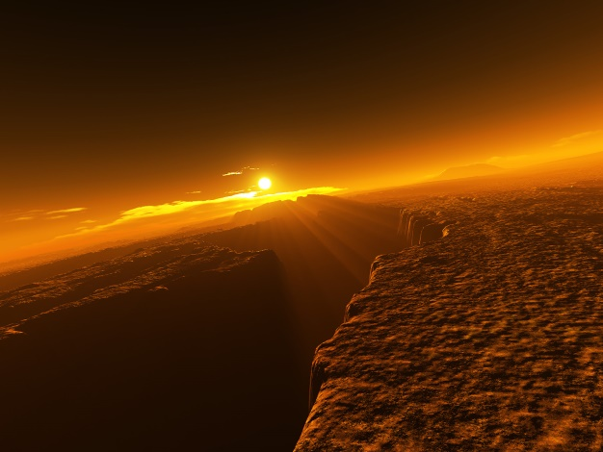

**Or**

* Low polygon graphics

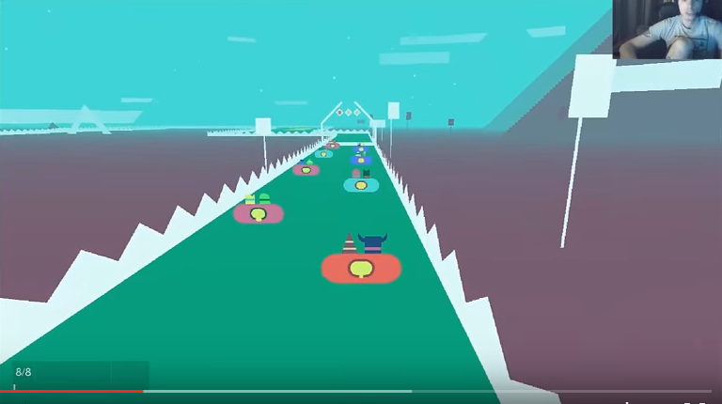

<https://youtu.be/sJIvS9qNbms?t=2m11s>

## Audio

* Ambient space sounds in the background, but no music.
* Magnetic force field/Lightsabery sounds when turning or drifting makes you feel like you are not just controlling a car, but a spaceship
* Engine sounds from your spaceship makes you really feel like your racing
* Shooting sounds sound like lasers, for the space feel
* Feedback sounds on almost everything you do.
* Space music when you are in the menu to get you excited for the game.

# Screen Passage

WIP

# Formal Elements

## Players

* **How many players can play the game**
* 2-4
* **Is there player interaction**
  + Yes, the players race against eachother and try to shoot eachother during the race. De spelers crashen als ze dood gaan, maar respawnen weer. Er is dus geen eliminatie.
* **Can I see what other players have accomplished during the game?**
* Yes, the players will be able to view the position of themselves and the other players during the race. They will also see the finish times at the end of the race.

## Objectives

* **What is the goal of the game**
* The goal of the game is to win the race by shooting your opponents down and ending first
* **How does the player know what the goal is**
* There will be a small explanation available in the menu Echt niet. Geen uitleg, hooguit een plaatje waar de controls worden uitgelegd, dat betekend slecht game design. De speler heeft meteen door dat het een race spel is en komt er vanzelf achter dat je kan driften (door bijvoorbeeld naar de settings te gaan) Er hoeft niet uitgelegd te worden hoe je moet racen, dat spreekt voor zich. Wat schieten betreft daar komt de speler vanzelf achter. (learning curve).
* There will be audio and visual feedback upon hitting opponents.
* **How can the player reach their goal?**
* By completing the race track first and shooting the other racers while avoiding their bullets

## Procedures

Controls Ik denk dat het makkelijker is als de powerup meteen actief is, dit zorgt ervoor dat je misschien soms niet het wapen hebt wat je wilt maar dat is ook wel weer leuk denk ik en pusht je om een beter wapen te pakken.

|  |  |  |  |
| --- | --- | --- | --- |
| Knop | Actie | | |
| Left Mouse Button |  | Shoot |  |
| Escape | Menu |
| Up / W | Accelerate |
| Down / S | Decelerate |
| Left / A | Turn Left |
| Right / D | Turn Right |
| Shift | Brake |
| **Controller** |  | **Action** |  |
| A |  | Gas |  |
| B |  | Break |  |
| Y/X |  | Boost |  |
| Jostick 1 |  | Stear |  |
| Left trigger |  | Shoot |  |
| Right trigger |  | Drift |  |
| Start |  | Pauze menu |  |

## Game

* Race and shoot
* Try to finish the race first by:
* Shooting at enemies to slow them down
* Avoid obstacles so that you don’t crash
* Avoid bullets so that you don’t get shot and crash
* Use your boost on tactical points in the map to go faster

## Rules

Objecten

* Maak een lijst van alle objecten in het spel die interactie met de speler of elkaar hebben (enemies, power ups, obstakels, etc). Beschrijf of deze objecten interactie met elkaar hebben, hoe dat gebeurd, wat er gebeurd en wat het resultaat daarvan is. WIP

## Resources

* Definieer alle resources
  + Wat is het effect van deze resources?
  + Waarom zitten ze in het spel?
  + Hoe vaak en waar zitten ze in het spel?

|  |  |  |  |  |
| --- | --- | --- | --- | --- |
| **Resource** | **Bonus** | | **Waarom** | **Wanneer** |
| Boost | Gives the player a full tank of boost |  | So that they can use it to increase their speed | At some key points in the track |
| Different weapon powerup (undefined) | Gives the player a different, mostly better, weapon |  | So that they can shoot down opponents even better | At some key points in the track |

## Conflict

* WIP

## Boundaries

* De speler kan niet naar achteren schieten. Removed jumping bullet

## Outcome

* A score relative to other players based on your placement during the race.
* A time based on the time you took to complete the race.

# Dramatic Elements

## Challenge

* **What is the challenge?**
* Dodging objects while going really fast. Trying to win the race against multiple players while handling the multiple different strategies that can be used to play the game.
* **What is the buildup in the challenge?**
* You will crash multiple times during a race. Meaning someone with catch up with you and take the lead instead. This builds up your need for speed and winning. The more the players play the game they better they will get. Therefore the challenge depends on the skill of the player and of his opponents. The better they are the rougher it will be to correctly handle all of the different options available to the players. (Dit zou beteken dat als er alleen 2 spelers mee doen altijd, dat er geen buildup is).

## Play

* It’s a race game where you compete with other players. Due to the inclusion of basic shooting mechanics, powerups and multiple ways to complete the track there are multiple different available strategies

## Premise

* You are part of a Space Race and you want to win. Enjoy.

## Target Audience

* 12-30 year old gamers.
* Average gaming experience.

Visueel

Lees summary

# Audio

Lees summary